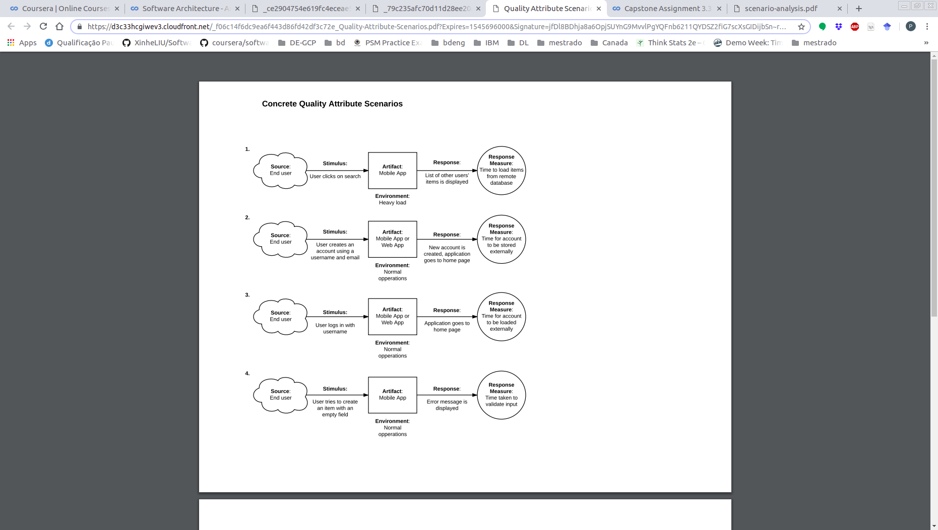
On this first scenario its possible to poins out a sigle risk. The system may not comply with the ASR requirement of less than one second to complete a task. During tests the time of response was between 2 and 5 seconds.
The second scenario presents another risk, this one is related to security. Due the system do not require password to logun, requires only user name and e-mail.

This third scenario is demonstrates a trade off, because if the user logs into the system just with the user name. In this case the trade off was related to security/privacy, allowing any one login in with any user name or just register a user name with any e-mail presents us the trade off.
This scenario is an example of Non-risk, due to the flow of the user attepmt to create a nameless item triggers a error message warning the user about the problem.

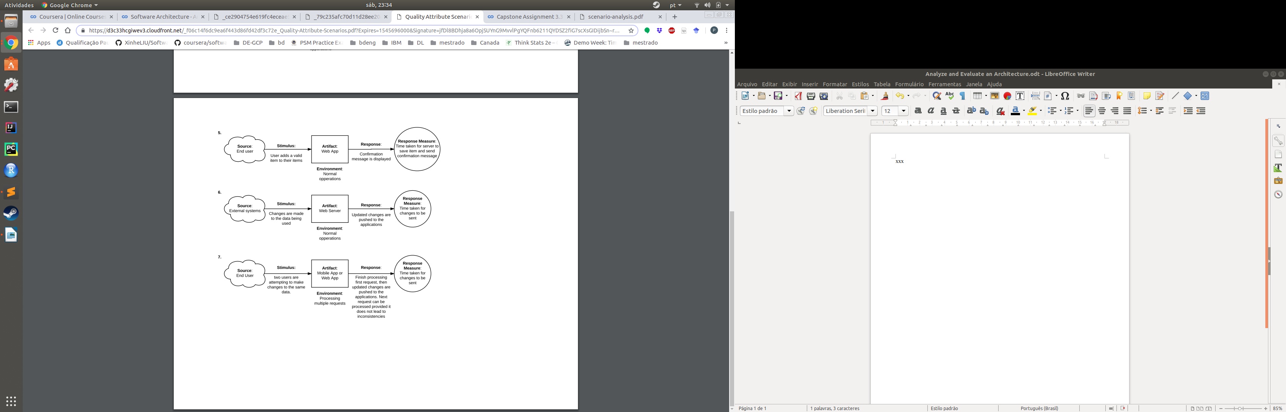
Another non-risk, due the operation performed by the user had ended sucessfuly and the system response was under the expected.

This scenario presents a sensivity point, the sync of data – the user may be using stale data. Invert the push strategy to pull on the data sync can minimize the problem.
It’s a non risk, the system treats multiple attempts by locking the resourse and executing a single operation at a given time., this leads to fault tolerance.

